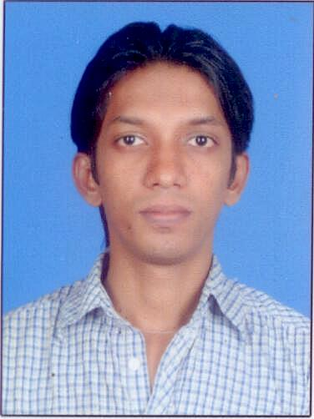  Nishad. T K.  Mob: + 91-9846901319 (India)  Email:  mail2nishadtk@gmail.com  Personal Data:  Date of Birth : 10/10/1985  Sex : Male  Father : kunchimon T.  Nationality : Indian  Marital Status : Single.  Mother Tongue : Malayalam  Languages Known: English, Tamil, and Malayalam.  Passport No : F0152544 | Career Objective  - To secure a responsible and challenging career as a Managerial Professional in a growing organization and to contribute my best for the organization's success.  Education  - Master of Business Administration (MBA)  Specialization in Finance and Marketing- University of Calicut.  - IATA FIATA and IATA DGR (speed wings aviation academy Cochin)  - B com Co-operation (University of Calicut)  Skills  - Good Communication Skill  - Good Listener  - Team Facilitator.  - Extreme Dedication.  Technical Expertise  - Microsoft office  - Tally  - Computer hardware  Areas of Interest  - Finance  - Administration  - Marketing  Achievements  - Done major project work titled “A study on financial performance analysis of Geojit securities ltd ”  - Done minor Project Work titled “ A study on the perception of Dr Bins ayurvedic products among retailers and doctors in malappuram district”.  - Active participation in the conduct of management meet “Mesmerize 2008”.

Academia
Year | Institution | Course | Marks
2007 – 2009 | MES College of Engineering, Kuttippuram. | Master of Business Administration (MBA)  ( University of Calicut ) | 60.00%
2006 – 2007 | Speedwings Aviation academy Cochin. | IATA FIATA AND IATA DGR | 85.00%
2003 – 2006 | Prathiba Arts and Science College, punnayoorkulam | B.com Co-operation  (University of Calicut) | 51.00%
2001 – 2003 | ICA English Higher Secondary School, Vadakkekad | Plus 2 (Commerce) | 60.00%
2001 | ICA English Higher Secondary School, Vadakkekad | SSLC | 53.00%

Hobbies
- Share trading
- Traveling.

References
Mr. Musthafa.
Department :Accounts ,accountant , Abu Dhabi, UAE.
Mob: 0556685439
Mr. Kunhimon T.
Department : Ministry of economy, UAE, Abu dhabi.
Mob: 0505215651

Work Experience:

1 ) August. 2009 to March 2010 :Dhanalaxmi bank, Kerala, India

Position Held : Sales Manager .

1)March. 2010 to June 2011 :TCM Trade Links.,Kerala, India

Position Held : Administrator cum Accountant.

WORKS UNDERTAKEN
Administration and work allotments.
Prepare book of account.
Data entry.
Verification of job sheets.
Maintaining payable.
Payroll preparation.
Petty cash handling.

